Titanic Survival Prediction using Machine Learning
CodSoft Machine Learning Internship
Prepared by: Ayush Mishra

Objective
Develop a machine learning model to predict passenger survival using the Titanic dataset.

Introduction
This project covers data preprocessing, exploratory data analysis, feature engineering, model training, and evaluation.

Dataset
Source: Kaggle Titanic Dataset
Total records: 891
Target column: Survived

Libraries Used
Pandas, NumPy, Matplotlib and Scikit-learn.

Data Cleaning
Filled missing Age values with the median, Embarked with the mode, and removed the Cabin column due to excessive missing values.

Exploratory Data Analysis
Visualized survival distribution, survival by gender, and age distribution.

Feature Engineering
Removed unnecessary columns and encoded categorical features.

Train-Test Split
Split the dataset into 80% training data and 20% testing data.

Model Training
Trained a Random Forest Classifier.

Model Evaluation
Achieved approximately 82.12% accuracy. Evaluated using confusion matrix and classification report.

Screenshots
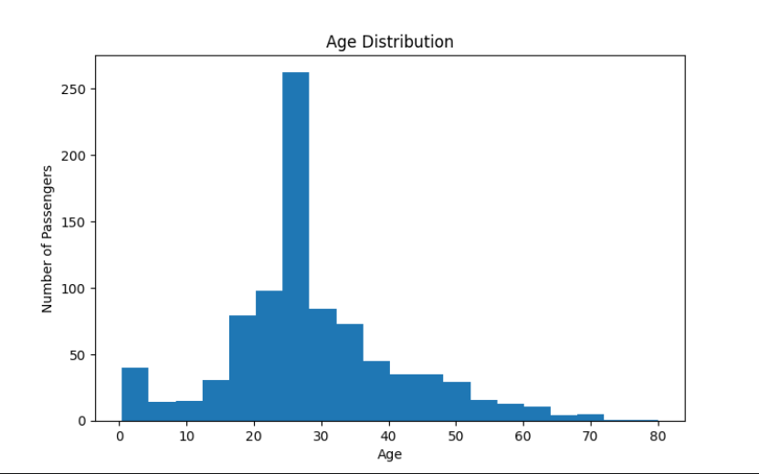

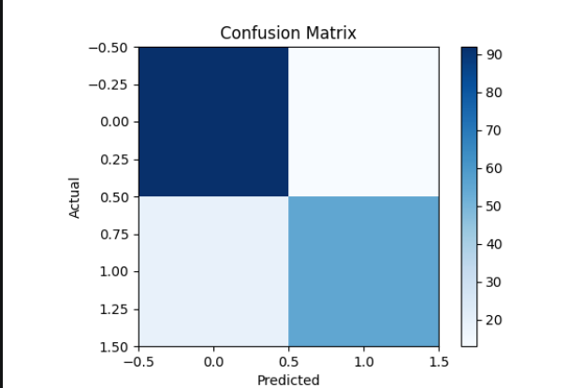

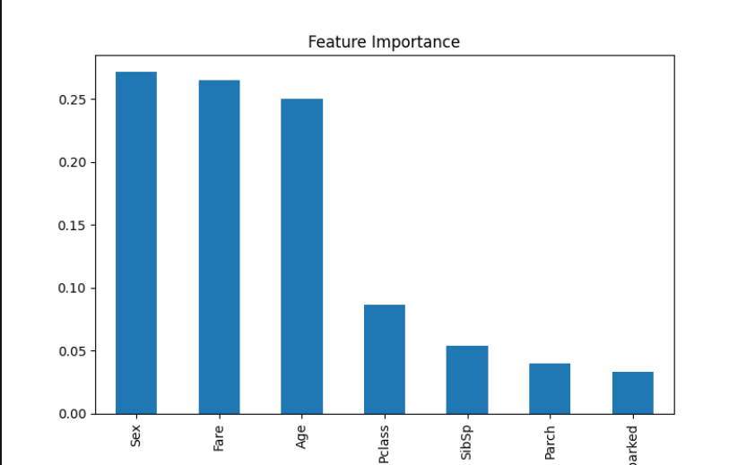

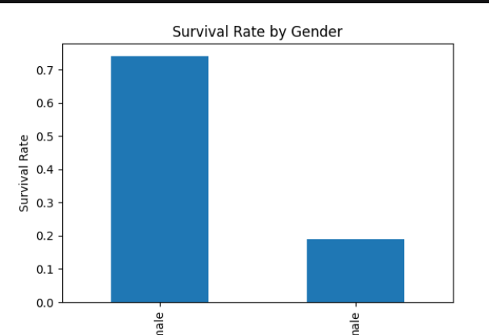

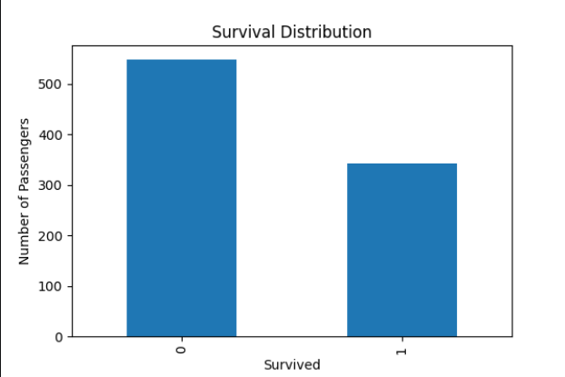

Conclusion
The Random Forest model successfully predicts Titanic passenger survival with good accuracy and demonstrates a complete machine learning workflow.

Future Scope
Performance can be improved using hyperparameter tuning and additional feature engineering.

